Appendix 9: New Features in v3.5 B
Port Flow Analyzer has had many updates since this user manual was written for the original v3.0 for Windows. These include
3.0 A through v3.0 E, v3.5 and now v3.5 B. For the features added to the v3.5, refer to the Readme.doc file (click on Help, then Display Readme.doc File) in the program. Listed here are features introduced in v3.5 B. Also, v3.5 B has a more advanced version we call “Head Porter”. So now there are 3 versions of Port Flow Analyzer:
- Basic Version
- Professional (Pro) Version (includes all Basic features and more advanced Pro features)
- Head Porter Version (includes all Professional features and more advanced Head Porter features) Here is a listing of the major enhancements and new features for v3.5 B.

Data Recording:
In Test Options, you can now select to record port velocity data at 3 depths in the port. See Figure A41, 47. Head Porter only.

Several enhancements to Port Velocity Report for Head Porter version have been added, to allow more averaging for all possible combinations of recording port velocity. See Figure A42. Head Porter only.

A new Preference to allow for English units of CFM, Deg F, inches of water pressure, etc. but mm valve, lift and engine dimensions has been added. See Figure A43. Head Porter only.

The Electronics or FlowCom screen has been enlarged in its default setting. You can still enlarge to most any size you want by turning on the appropriate Preference setting. See Figure A43-B. All versions.

You can now include a “gauge” (bar graph) for some readings on the Electronics or FlowCom screen. This gives you a graphical representation of the stability of the readings and if the readings are going higher or lower than expected values. See Figure A43-B. Head Porter only.

Data Analysis (including Graphs and Reports):
You can create custom, user defined graphs, where you choose what data gets included. For example, you can graph CFM and Swirl and % Exh/Int on the same graph. See Figure A44, A45. Head Porter only.

Program now allows for graphing Flow results corrected to 2 different test pressures. See Figure A46. Head Porter only.

You have several options to allow for more options for doing Port Velocity Graphs. This is an extension to the feature to be able to record Port Velocity for many more data points. See Figure A47. Head Porter only.

You can now specify if you want the Test Piece picture to be drawn smaller in printouts in portrait mode. (See “Other” category for Test Piece picture.) This can allow for more printed text to be included with the graph on 1 page. NOTE: In landscape mode, the Test Piece picture is always drawn small on the same line as the test title. The Test Piece picture can also be printed in reports. See Figure A48. Head Porter only.

You can now select a single cylinder to make graphs which require a valve lift profile, like Flow Area and Pseudo Flow Velocity. In previous versions, only the Average Flow for the entire head was used. Head Porter only.

You can now request the graph to be printed in a smaller height. This can allow for more printed text to be included with the graph on 1 page. See Figure A49. Pro and Head Porter only.

You can now select a Preference to have the graph NOT autoscale when you first open it. This can be handy if you are using some pre-defined scales and want to keep them for all graphs. Pro and Head Porter only.

Added a graph line thickness between Thin and Thick, called Thin 'Plus'. See Figure A50. All versions.

The graph line styles in the drop down menu of line thicknesses are listed together, with the appropriate check mark by the type currently used. See Figure A50. All versions.

You can now select larger legends (labels) in the graph screen. See Figure A50. Pro and Head Porter only.

Added label to better explain what cylinder or that Average of All Cylinders will be used for Flow Area and Pseudo Flow Velocity graphs. Pro and Head Porter only.

The graph screen now should more completely fill the available screen in most all situations. All versions.

Improved appearance of some printed graphs, especially in Landscape orientation. Previously the graphs had a border drawn around them. On the left side, the border could be broken. On the right side the legend (labels) could also be distorted. Now the border is not drawn in those locations. See Figure A49. All versions.

The graph choices have been simplified by eliminating many of the Int, Exh, and Int & Exh choices into just 1 choice. Now the program looks to a separate input of "Port to Graph" for this setting Int, Exh, and Int & Exh choices. See Figure A45. All versions.

Fixed bug where the Port Velocity Map was not being graphed correctly. Pro and Head Porter only.

Made Overlap Graphs go to zero at start and beginning of graph to look more correct. Pro and Head Porter only.

Fixed bug where graphs for % Exh/Int only showed the first cylinder on the head even though you requested all cylinders to be graphed. Pro and Head Porter only.

Added menu command 'Edit Printed Comments & Data Output' under the File option on the Graph screen in the printing options section. Pro and Head Porter only.

Program now includes more example cam files, the same files included in the new Engine Analyzer v3.4. See Figure A51. Pro and Head Porter only.

Hardware:
Pro version now allows for Performance Trends’ motor controller to be used. See Figure A52. Pro and Head Porter only.

Program now allows for a USB switch to be used for starting to record data. This option does not present conflicts with some features of the SuperFlow Flowcom. This is done buy purchasing the proper switch from Performance Trends, then going into FlowCom or Electronics screen, clicking on Options at the top, then select the USB Switch Option. You must also set the proper Com Port for the USB Switch under this option also. See Figure A53. All versions.

In the Bench Specs screen, the program now allows for Valve Opener for any Pro version. Pro and Head Porter only. Added Hot Wire (hot wire anemometer mass air flow sensor) as a Custom Bench Type. See Figure A54. All versions.

Other:
The program now lets you "Filter" tests in the library for finding tests of a certain date, certain file name, etc. Pro and Head Porter only.
When quitting program and you select 'Cancel' for Saving Changes to current test file, now the program keeps program open. Before v3.5B, it continued shutting down. All versions.

The option for using a 2 pulse swirl meter, to be read directly with a FlowCom (no Performance Trends electronics) has been added. In addition, a special calibration factor for this 2 Blade Swirl meter is also possible. Pro and Head Porter only.

Fixed bug where reports may be requested for intake and exhaust ports, but only intake ports were reported. All versions.

Fixed bug where the cylinders you may "Pick" for a report were not being shown clearly (another input was in front of it). All versions.

Fixed bug where FlowCom/Electronics screen could be off screen too high or too far to left. All versions.

Fixed bug where Test Comments were not being shown in the Preview when opening some older Port Flow files. All versions.

Updated a text file to more accurately show Mass Flow correctly for gm/sec and lb/min, and correct for proper air density specs. Pro and Head Porter only.

Program now hides the 'Range' column for bench types which have only 1 range, like EZ Flow, JKM, new Hot Wire, and LFE. See Figure A55. All versions.

Program now shows the Company Logo graphic on the main screen. See Figure A55. Pro and Head Porter only.

Added option to include a Test Piece Pic with your data file. This could be of the head, carb, etc. It is displayed on the main screen and in printouts if you choose to included it from the "Print Options" list (graphs and reports). See Figure A55. Head Porter only.

Program no longer 'nags' as much about using the CFM at 0 lift as Leakage. All versions. New Example Flow Files have been added to show new features.
Figure A41 More Port Velocity Options
Click on Test Options at Main Screen

New choice for Type of Port Velocity data: Record 9 points across the port (3 rows of 3 positions) at all lift data points.
New option of “Depths in Port” to allow you to record data at different depths in the port, 1 depth (the only choice in previous versions and in the current Pro version), 2 and 3.

Different depths marked as “A”, “B” and “C”.
Labels let you know which data points are being graphed.

Arrow shows you flow direction.
Click on Graph button (shown here as “Layout” because Graph is being shown) and with more than 1 depth you have 2 options. Front View (as done before) or new Side View (as shown here. The depth in Front View (A, B, or C) or the depth in Side View is determined by which cell is currently highlighted in the grid. In this case, it is side depth 3 (farthest from viewer).

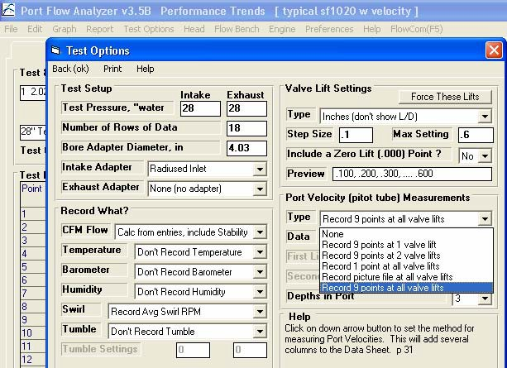
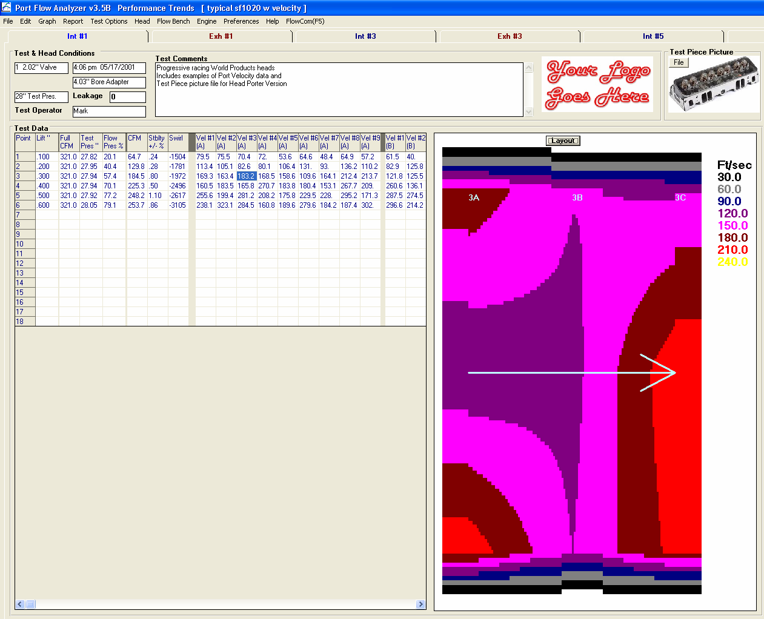

Slide slide bar left to see all the entry points for port velocity.

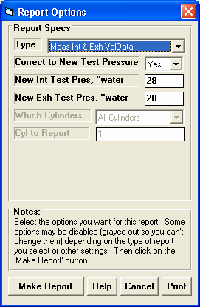
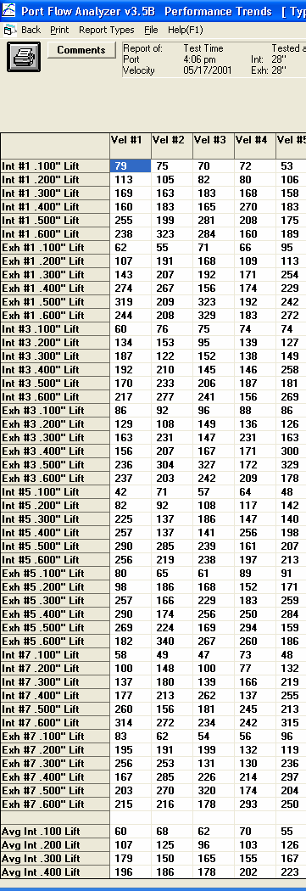
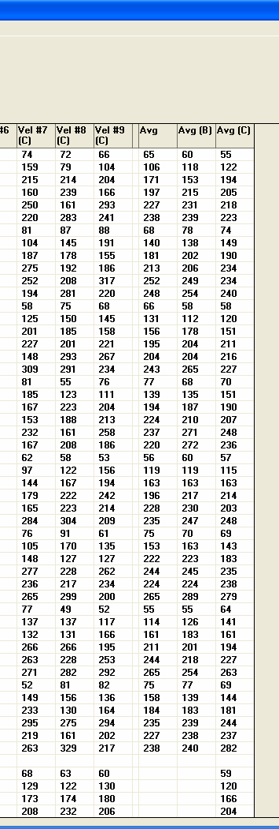
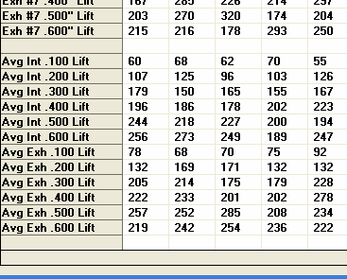
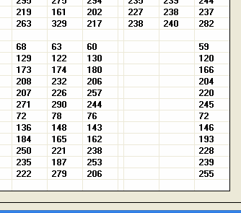
Figure A42 Port Velocity Reports
Last columns of report

First columns of report

“C” for depth C
No letter indicates depth

Choose this Report Type
Averages for depths A (blank), B and C

Bottom rows of report.

Averages for all valve lifts at each position and depth across all
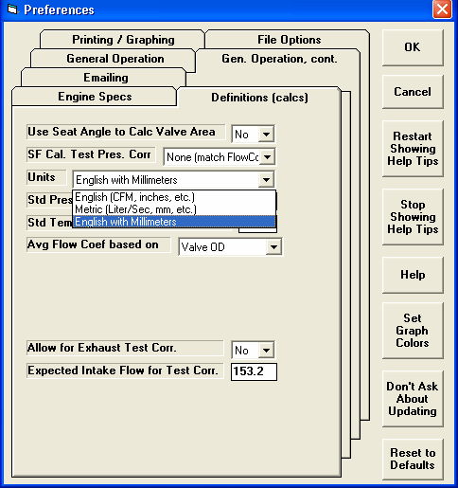
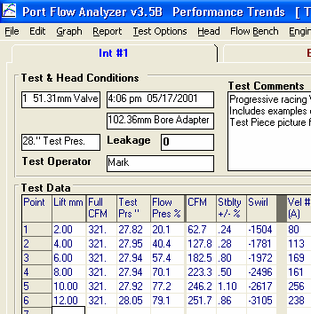
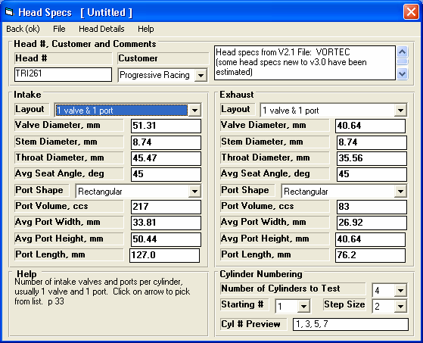
Figure A43 English Units but Using Millimeters for Lift and Dimensions
Flow in CFM
Lift in mm
New choice in Preferences

Engine dimensions also in mm
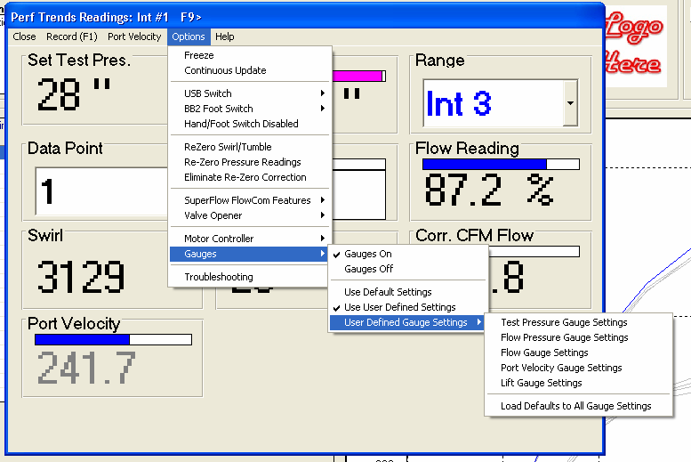
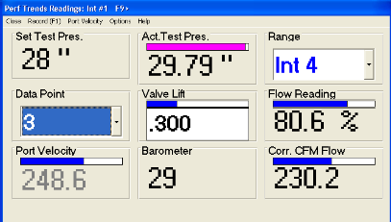
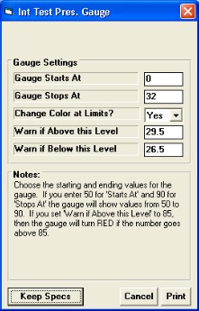
Figure A43-B Bar Gauges for Selected Readings.

Gauge Options
This option lets program pick the scales for the gauges.

Choose options to change the settings for each particular gauge, the high and low value of the bar graph, and any limits to be flagged out in either red or yellow color (warnings or cautions).
Click this and program will generate “reasonable” scales for the gauges. This is useful when first turning on “Use User Defined Settings” because these will all be blank.

Bar gauge with real time updates. This one shown in red because reading went above user defined limit of 29.5. See screen to right for setting scales and limits.
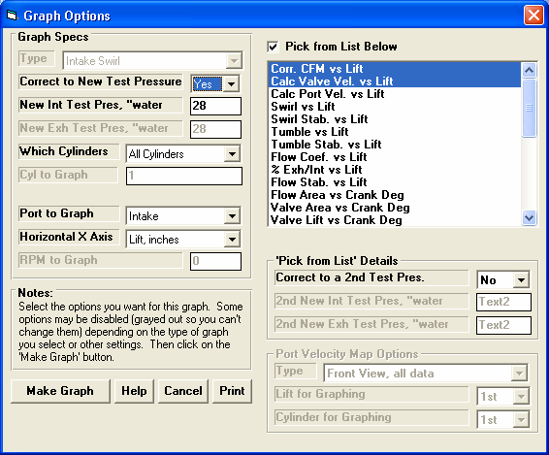
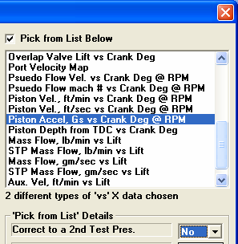
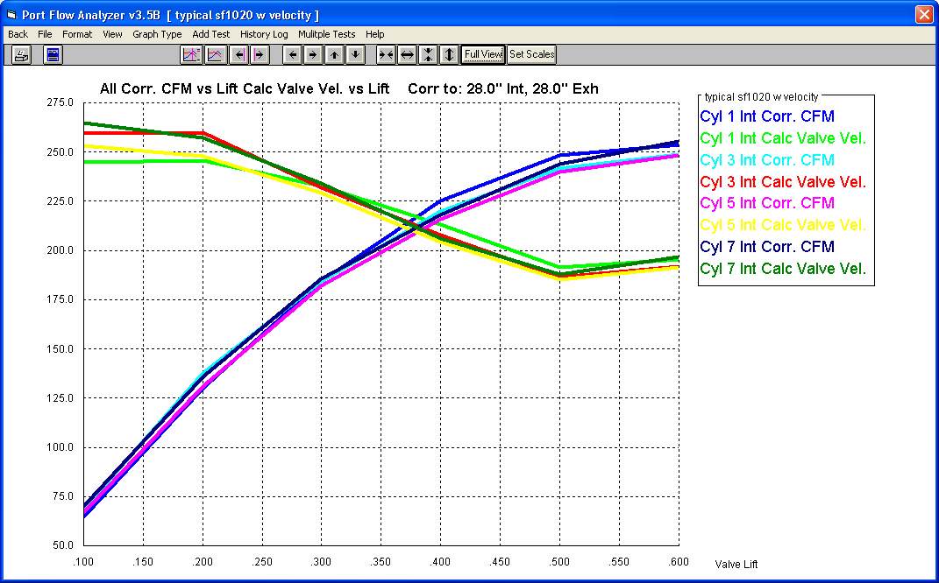
Figure A44 Custom, User Defined Graphs
Check here to get these Custom Options
Choose what data you want graphed.

If you choose data types which are graphed vs different parameters (like in this case lift and crank degrees) a warning is given here and only one data type will be graphed.

Graphs of Intake Corr. CFM and Calc. Valve Vel. corrected to 28” water for all intake ports.
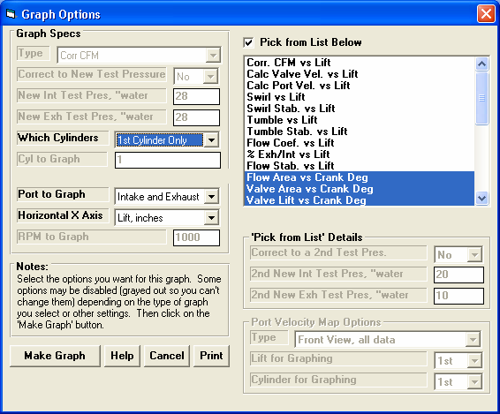
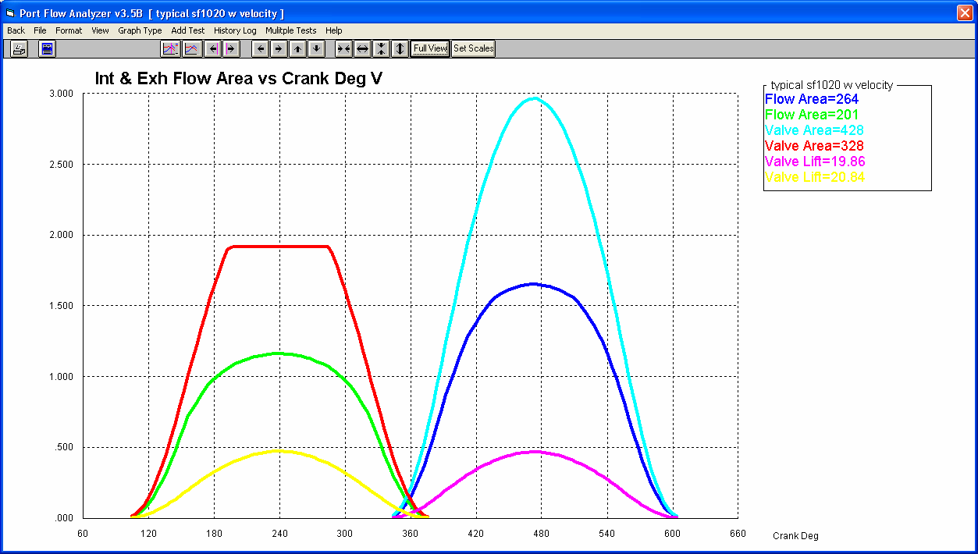
Figure A45 Custom, User Defined Graphs
Check here to get these Custom Options

Pick your graph data types

Which Cylinder(s)

Which Ports
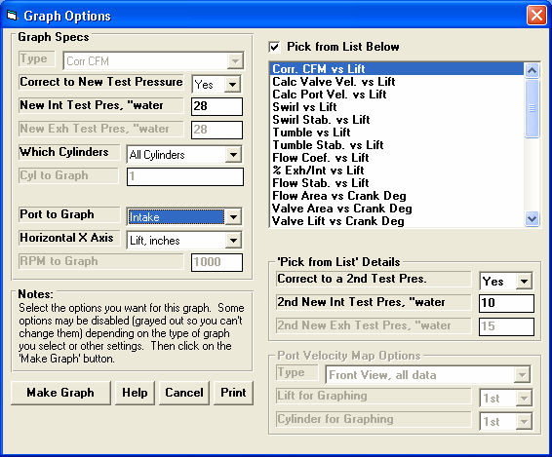
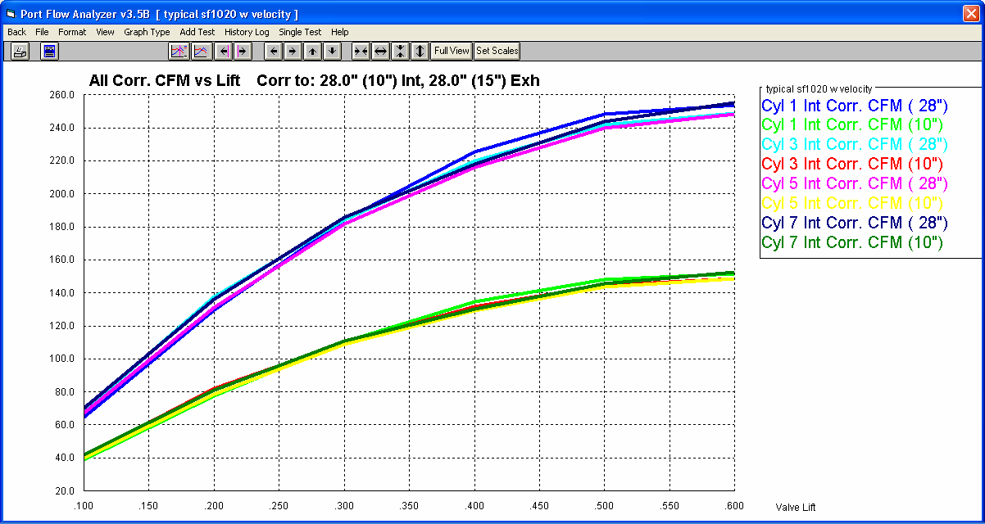
Figure A46 Custom Graph at 2 Test Pressures
Choose Corr. CFM vs Lift ONLY. Note, correcting to 2 test pressures only works for this data type.

Set this to Yes.
Select the Second Test Pressure you want the data corrected to. Note: The First Test Pressure is set as “New Int Test Pres, ‘’water” on the left side.

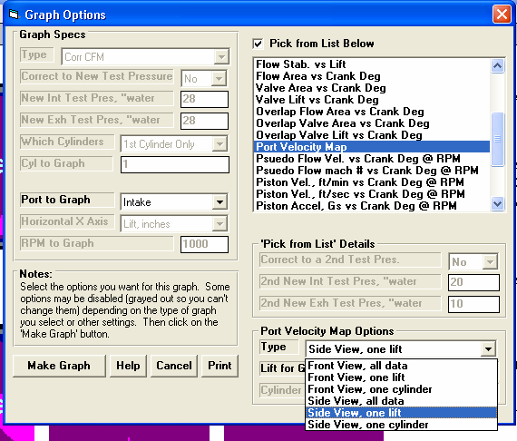
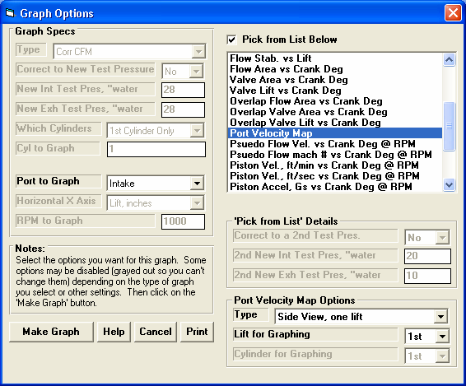
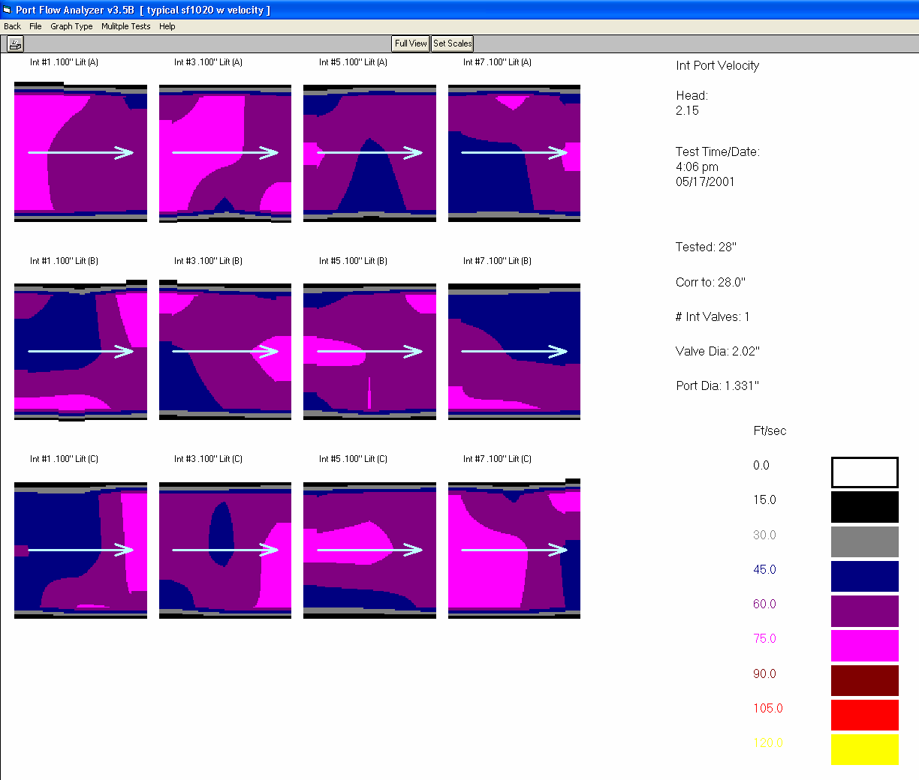
Figure A47 Custom Port Velocity Graphs

Pick Port Velocity
Pick View and what lifts and cylinders to graph
Pick Lift or Cylinder for graphing, which ever needed

The breakdown of the scales for various port velocities can be set here. This was true in versions prior to V3.5B.

The color choices here can be set in Preferences. This was true in versions prior to V3.5B.
Figure A48 Smaller Test Piece Picture in Portrait Mode Printer Orientation
Choose to include Test Piece Picture in printout

Picture Smaller. This only applies to Portrait page orientation.
You can choose to make the picture smaller, which can give you more room on a printed page.
Click here for screen to right. This feature is also listed under Format.
Landscape always does this.

Smaller NOT selected, picture is larger.

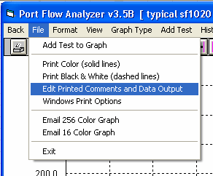
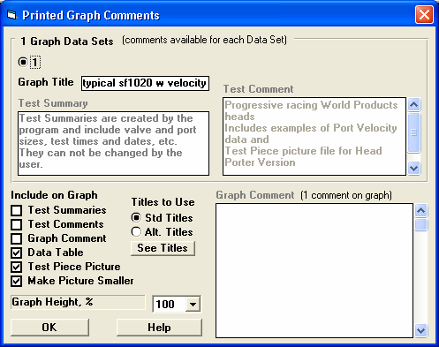
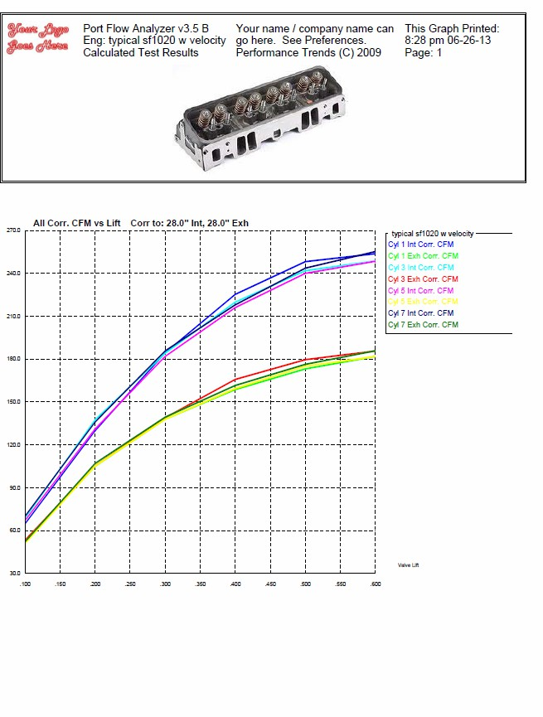
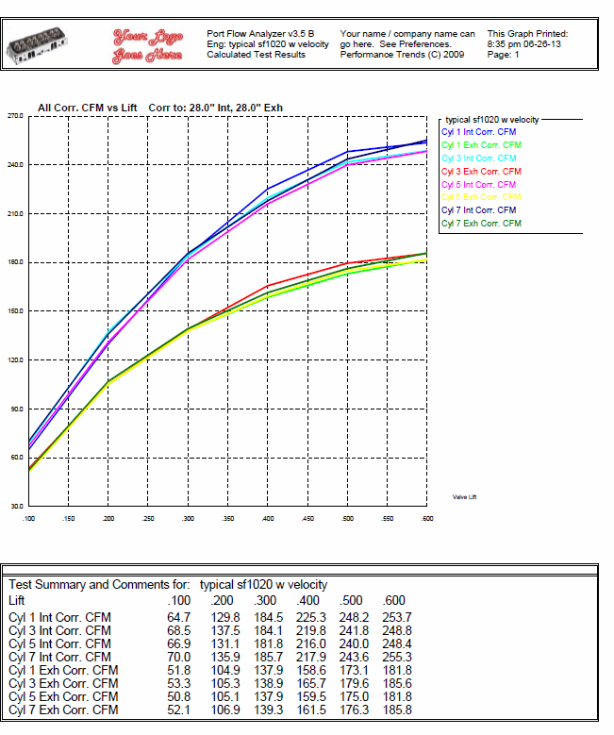
No room on this page for Data Table.

Room for Data Table on a single sheet.

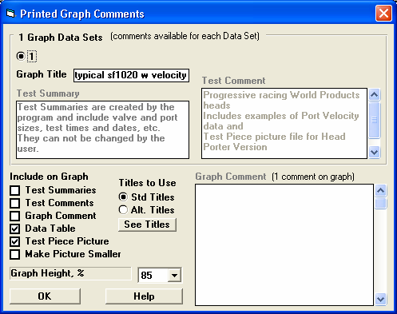
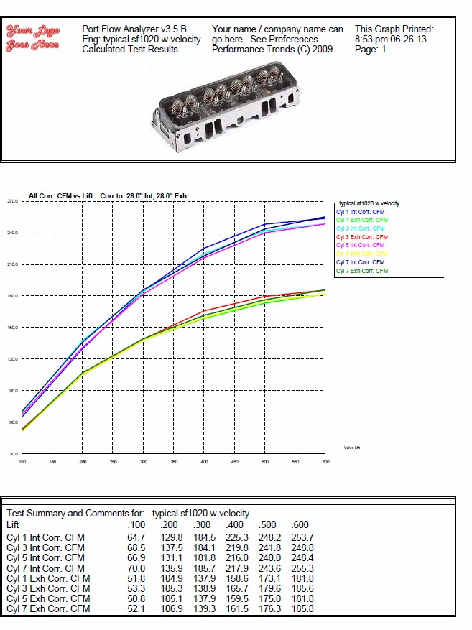

Figure A49 Smaller Graph Fits All Results on 1 Printed Sheet

Choose a % to reduce the height of the printed graph. This option works in both Portrait and Landscape printer orientations.

Printed graphs no longer have a border on the left and right sides around the graph. This border often had a slight “jog” in it depending on printer, screen resolution, etc. Now without a border, there is no “jog”.

The graph can be printed to include the Data Table even though the Test Piece picture is printed large.
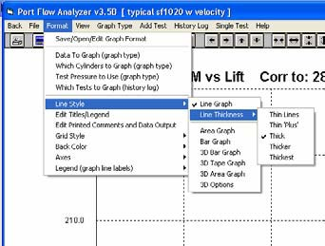
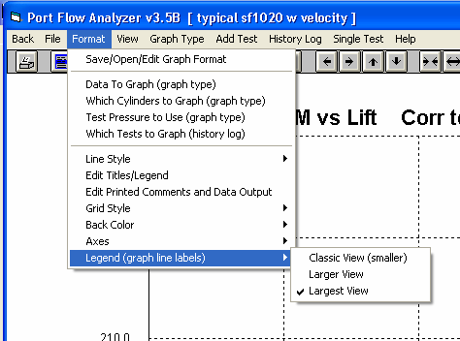
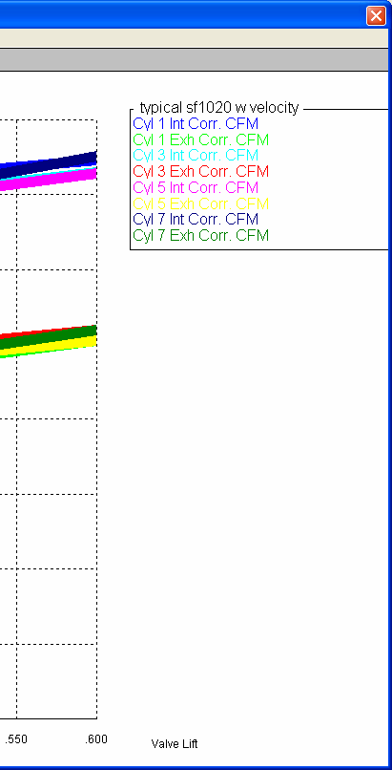
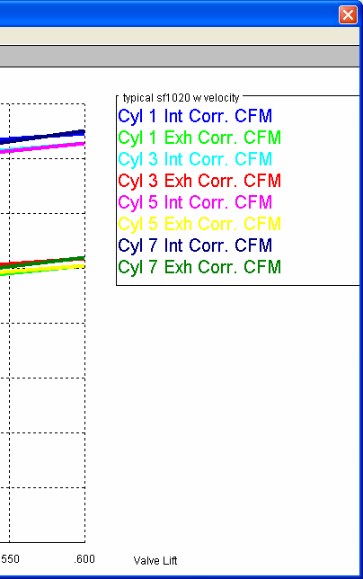
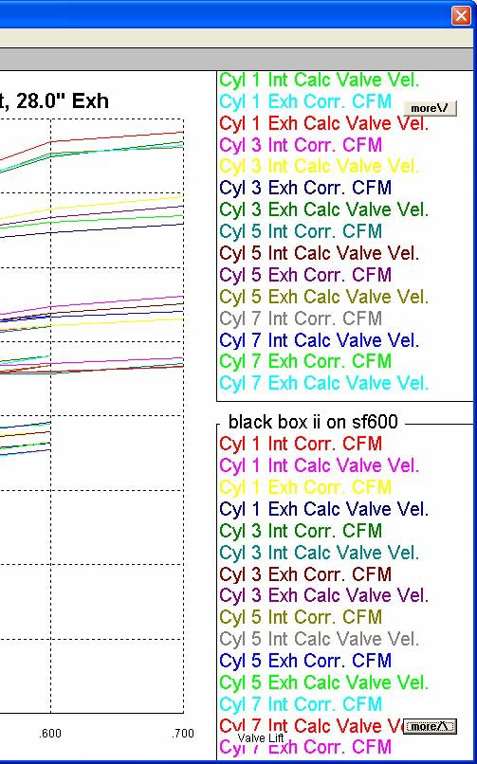
Figure A50 New Graph Features: Line Thickness and Larger Legends

Various combinations of line thickness and Legend Size

If the legend is too large to fit on the screen, “more” buttons appear at top and or bottom. You can click on these buttons to scroll through the labels.
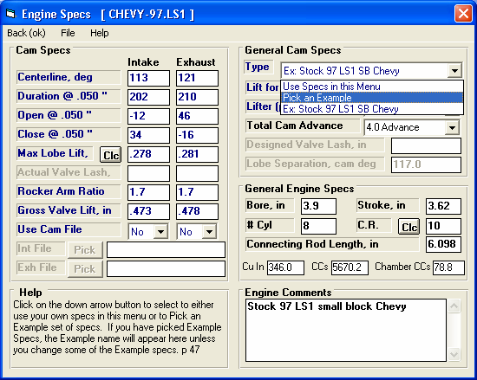
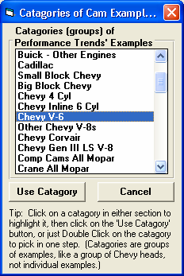
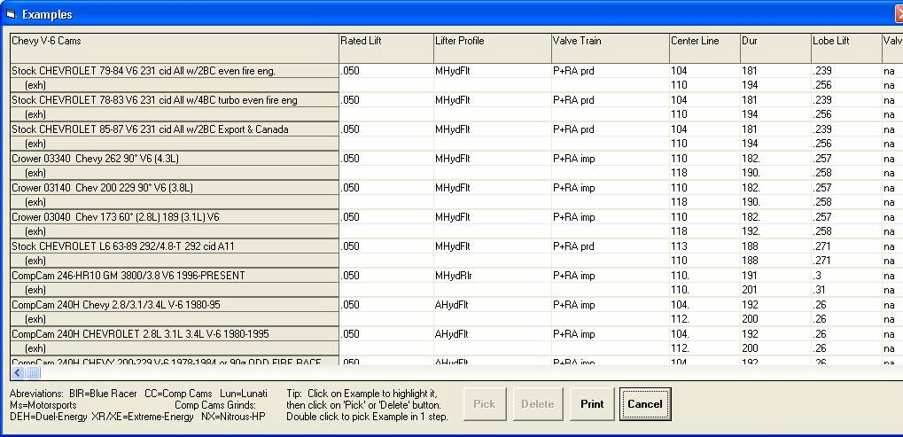
Figure A51 More Example Cams for Engine Specs Screen

Choose Pick an Example
Choose a Category of Cam from a much larger list than in earlier versions.

Pick the particular cam from a large list of cams, almost double from what was in earlier versions.

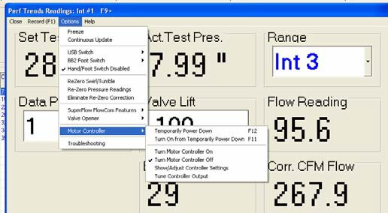
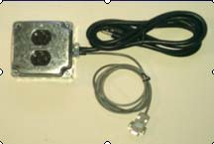
Figure A52 Motor Controller to Control Test Pressure
Control lines from special Black Box II
Motor controller options. Current design only works with special Black Box IIs.
Controlled AC power to bench
AC power in
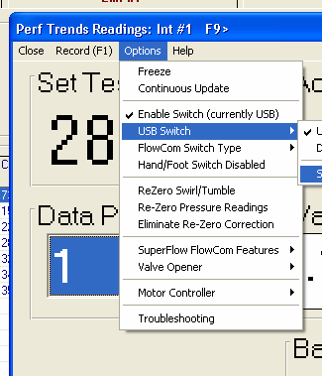
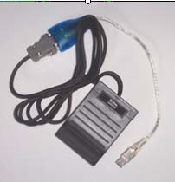
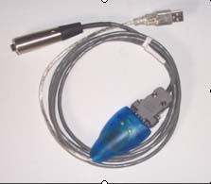
Figure A53 USB Recording Switch
Under Options, click on USB Switch to see options.

First, click on Set USB Switch Com Port and set that to one of the available Com Ports shown by the program when you click on this.

Then click on Use USB Switch to tell program to look for this switch input for recording data. F1 keystroke will still work also.
Foot Switch w USB
connector
Hand Switch w USB
connector
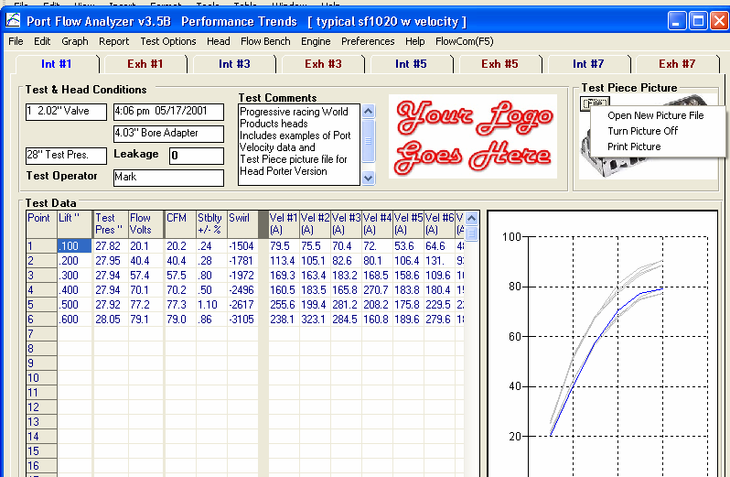
Figure A55 Main Screen: No Range Column for Certain Benches and Logo Picture
No Range column for this Hot Wire type of bench.
Click on File button for options for the Test Piece picture.
Company Logo shown on Main Screen
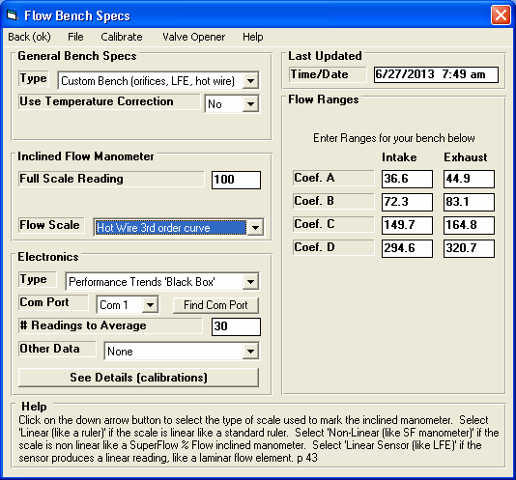
Figure A54 New Bench Type: Hot Wire Anemometer
Enter the 3rd order coefficients for a curve of flow vs voltage. Most likely you will have to obtain this from Performance Trends after you run a calibration on your bench.
Choose Hot Wire
Choose Custom Bench Type

